U.S. Tech Job Market and Skill Analysis
JobAvenir | Project Milestone 2: Database Implementation

Part 0: Project Header and Milestone 1 Updates
Item | Details
Project title | U.S. Tech Job Market and Skill Analysis
Project name (website name) | JobAvenir. "Avenir" means "future" in French.
Team members | Mounika Kage; Sheetal Sreedhar
Course | Advanced Database Technologies
Repository | https://github.com/sheetalsreedhar/JobAvenir

Changes since Milestone 1
Since Milestone 1 we changed the job-posting source, the database system, the scope of the O*NET data and parts of the design. Table 1 lists each change and the reason for it.
Area | Milestone 1 plan | Milestone 2 implementation | Reason
Job-posting source | Greenhouse API | Jobicy API | Greenhouse needs a board token for each company, which is not the company's domain name, and it cannot search by role. Jobicy is public and can be searched by region and industry.
Database | Snowflake | MySQL 8.0 (MySQL Workbench; MAMP on one laptop) | Snowflake is a paid subscription. MySQL is free, runs locally and enforces primary keys, foreign keys and CHECK constraints.
O*NET data | Technology (software) skills | Technology skills plus Essential and Transferable skill ratings | A skill-gap comparison needs general skills such as Critical Thinking as well as tools such as Python.
Job collection | Searches for five role titles | All U.S.-eligible postings: one all-jobs search and one search per Jobicy industry (16) | The role searches only match job titles and returned 74 postings. The broader collection returned 845 unique postings over two pulls.
Application | Streamlit dashboard | Planned for the next milestone | This milestone covers the database. Three synthetic demo profiles stand in for app users.
Table 1. Changes to dataset, technology and scope.
The tables planned in Milestone 1 were also refined during implementation (Table 2).
Milestone 1 table | Milestone 2 table(s) | Change and reason
OCCUPATION | occupations | Same key and fields. The suggested education_level was not added because neither data source provides it.
SKILL | skills | One table for all three O*NET skill types. Added skill_category (Technology, Essential, Transferable), skill_source (O*NET or Jobicy) and onet_element_id, which traces each Essential or Transferable skill back to O*NET.
OCCUPATION_SKILL | occupation_technology_skills and occupation_skill_ratings | O*NET describes two different links. A technology skill has Hot Technology and In Demand flags. An Essential or Transferable skill has an importance score and a level score, each with a sample size, standard error and confidence interval that show how reliable it is. Each kind of link gets its own table.
USER and CAREER_GOAL | app_users | Merged. Each user has one target occupation, stored as target_occupation_id. Added created_at and is_demo, which marks the synthetic demo profiles. The planned education_level was left out until the app collects it.
USER_SKILL | user_skills | Proficiency is a whole number from 1 to 5. Added added_at.
MARKET_SKILL_DEMAND | View market_skill_demand | Computed from the job postings when it is queried, so it never goes out of date.
(new) | companies, job_postings, job_skills, job_titles, skill_aliases | Store the Jobicy market data and the O*NET alternative titles, and link Jobicy skill keywords to O*NET skill names.
Table 2. Milestone 1 tables and their Milestone 2 implementation.

Part 1: Database Schema and Design Rationale

1.1 Data model
Figure 1 shows the 11 core tables with their keys and the cardinality of every relationship. Figure 2 is the same schema reverse-engineered in MySQL Workbench. It also shows the seven staging tables, which hold the cleaned CSV files before loading, and the two views.
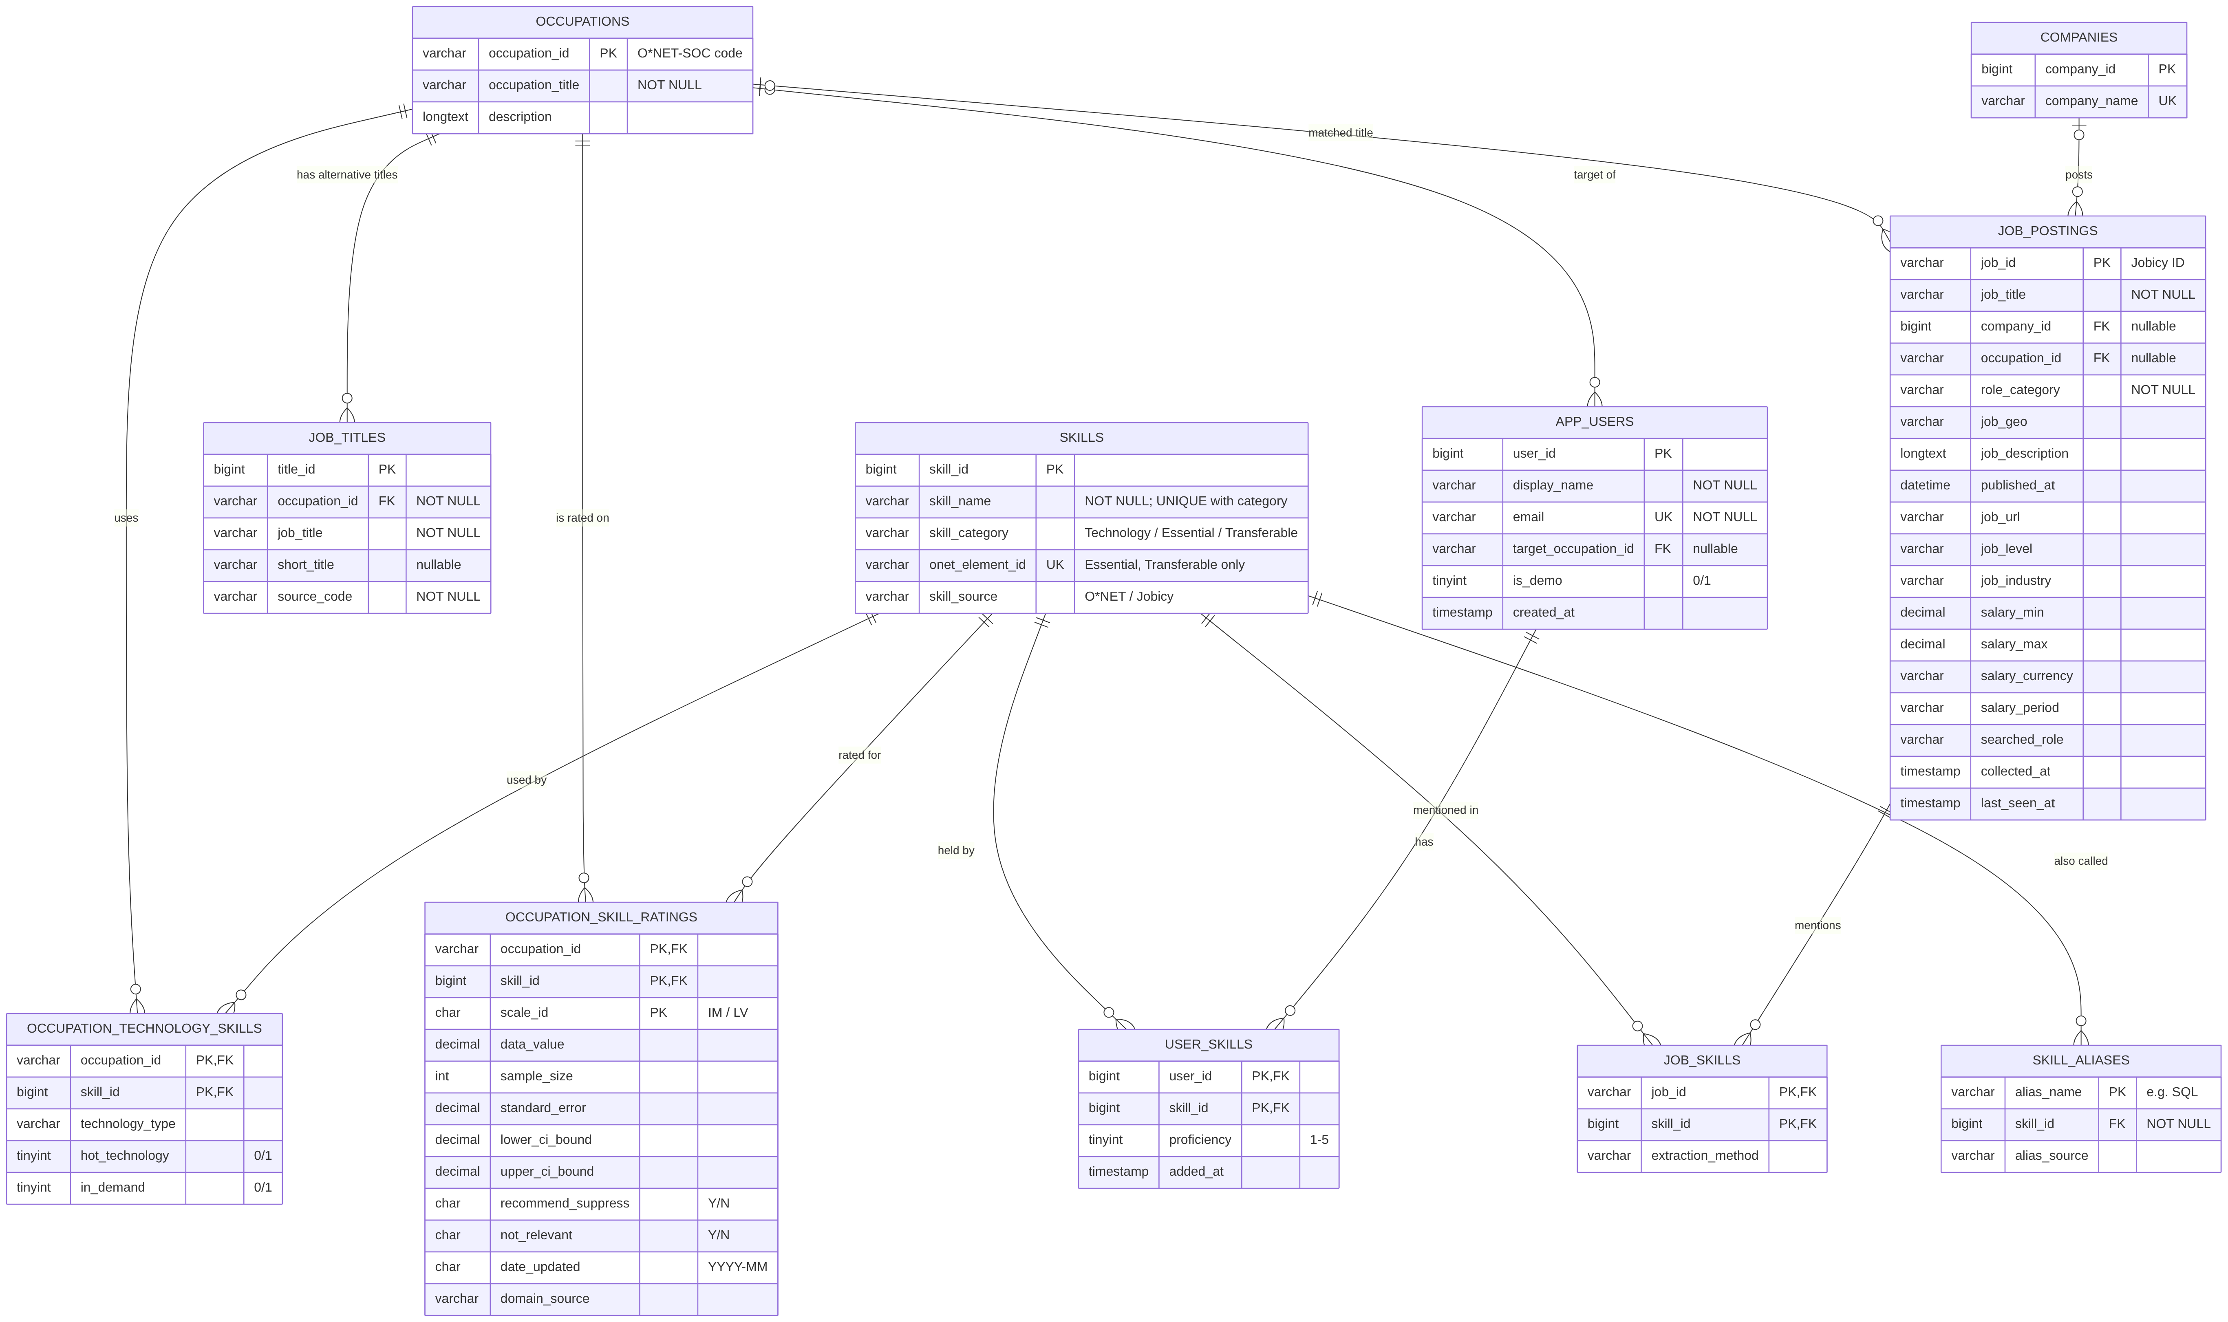
Figure 1. JobAvenir core data model. Crow's foot notation: || exactly one, |o zero or one, o{ zero or many. PK primary key, FK foreign key, UK unique key.
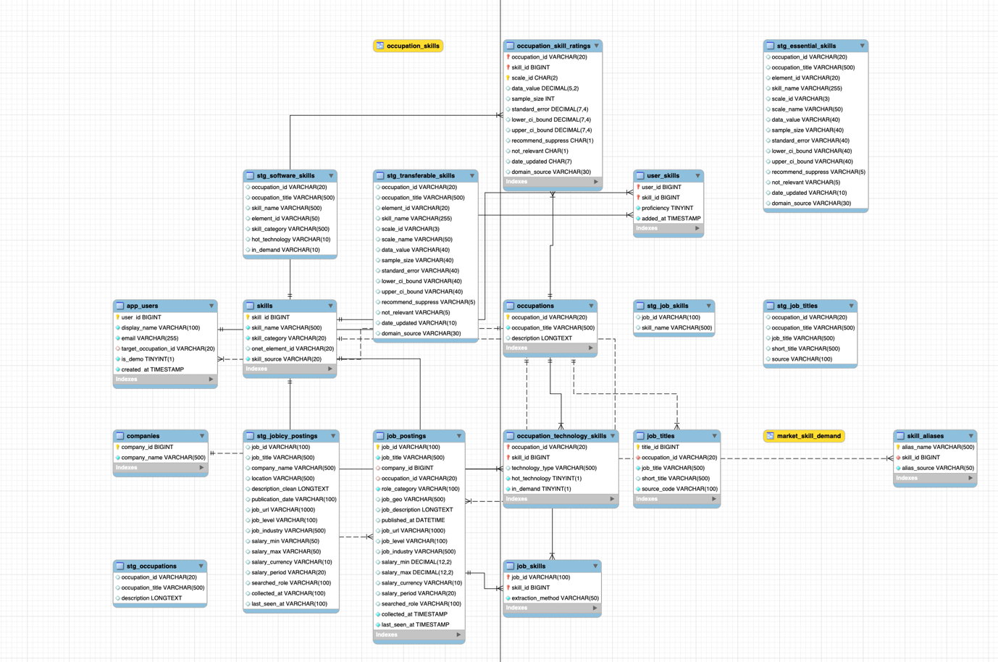
Figure 2. Implemented schema in MySQL Workbench, including the staging tables (stg_*) and the views.
The schema has 18 tables and 2 views in four groups:
- O*NET reference data: occupations, job_titles, skills, occupation_technology_skills, occupation_skill_ratings.
- Job market data from Jobicy: companies, job_postings, job_skills, skill_aliases.
- Application users: app_users, user_skills.
- Loading and reporting: seven stg_* staging tables and the views market_skill_demand and occupation_skills.
The relationships and their cardinalities are:
- occupations 1 to many job_titles. Every alternative title belongs to exactly one occupation.
- occupations many to many skills, resolved by occupation_technology_skills and by occupation_skill_ratings.
- job_postings many to many skills, resolved by job_skills.
- companies 1 to many job_postings. The company is optional (zero or one per posting).
- occupations 1 to many job_postings. Optional: it is set only when a posting's title matches an O*NET title exactly.
- skills 1 to many skill_aliases. A skill can have several other names; each alias names one skill.
- app_users many to many skills, resolved by user_skills.
- occupations 1 to many app_users. The target occupation is optional.

1.2 How the design supports users and application operations
The intended users are students and career changers who are exploring U.S. tech careers. The planned app has three main operations:
- Explore an occupation. Show the skills an occupation needs: tools with the O*NET Hot Technology and In Demand flags, and general skills with their importance and level. This reads occupation_technology_skills, occupation_skill_ratings and the occupation_skills view, which combines them.
- See market demand. Show how often current job postings mention each skill, by role. This reads job_postings, job_skills and the market_skill_demand view.
- Find my skill gap. A user saves a target occupation and the skills they have. The app lists the important skills of that occupation that are missing from the profile. This reads app_users, user_skills and the occupation_skills view.
All three operations compare skills that come from different sources. O*NET, the job postings and the user profiles all refer to the same row in skills, so one join on skill_id compares them. Jobicy postings name some skills differently from O*NET ("SQL" instead of "Structured query language SQL"). The skill_aliases table maps these names to the O*NET skill, so they also share one skill_id. Therefore a single query can place a skill's mentions in postings next to its O*NET flags and a user's profile (queries 8 and 9 in Part 3).

1.3 Normalization choices
The core tables follow third normal form: every non-key column depends on the whole key and on nothing else. The main decisions were:
- Skill names are stored once. The 63,700 rating rows refer to skill_id. Before this design, the skill name was repeated in every rating row.
- No scale name in the ratings. The name depends only on scale_id (IM = Importance, LV = Level), so it is not stored.
- Occupation titles live only in occupations. Other tables refer to occupation_id.
- Companies have their own table. A posting stores company_id, so each company name is stored once.
- Link tables resolve many-to-many relationships. Each has a composite primary key, for example (occupation_id, skill_id, scale_id).
- technology_type stays on the link. 151 of the 8,753 O*NET tools are grouped under different types in different occupations. So the type depends on (occupation_id, skill_id), not on the skill alone.
- Two link tables instead of one. Technology links and skill ratings have different columns. One table would leave most columns empty for every row.
Some denormalization is deliberate:
- Staging tables keep the raw CSV text, including repeated titles, so every loaded row can be traced back to its file. Queries never read them.
- role_category is stored on job_postings. It is derived from the title and the Jobicy industry during loading. Storing it means every query uses the same label, and each load recomputes it.
- job_industry, job_geo and job_level are stored as text. Jobicy sends them as free text, and they are only displayed or filtered. A posting can list several industries separated by "; ". Lookup tables would add joins that no current query needs.
- Market demand and the combined occupation skills are views. They are computed on read, so they hold no copies of data and cannot go out of date.

Part 2: Data Integrity and Constraints

2.1 Data types, identifiers and required fields
- O*NET codes are VARCHAR, so codes such as 15-2051.00 and source codes such as 08 keep their exact form.
- Surrogate keys (skill_id, company_id, title_id, user_id) are BIGINT UNSIGNED AUTO_INCREMENT. Jobicy's own job_id is the posting's natural key.
- Ratings are DECIMAL(5,2) and salaries DECIMAL(12,2). Collection times are TIMESTAMP in UTC. The O*NET update month is CHAR(7) in the form YYYY-MM.
- Flags are TINYINT(1) (0 or 1) or CHAR(1) (Y or N).
Table 3 lists the key, required fields, unique fields, foreign keys and checks of each core table. All foreign keys also use ON UPDATE CASCADE.
Table | Primary key | Required (NOT NULL) | Unique | Foreign keys (ON DELETE) | CHECK
occupations | occupation_id | occupation_title
skills | skill_id | skill_name, skill_category, skill_source | (skill_name, skill_category); onet_element_id |  | skill_category in 3 values; skill_source O*NET or Jobicy
job_titles | title_id | occupation_id, job_title, source_code | (occupation_id, job_title, source_code) | occupation_id to occupations (RESTRICT)
occupation_ technology_skills | (occupation_id, skill_id) | hot_technology, in_demand |  | occupations, skills (RESTRICT)
occupation_ skill_ratings | (occupation_id, skill_id, scale_id) | scale_id |  | occupations, skills (RESTRICT) | scale_id IM or LV; flags Y or N
companies | company_id | company_name | company_name
job_postings | job_id | job_title, role_category, collected_at, last_seen_at |  | company_id (RESTRICT); occupation_id (SET NULL)
job_skills | (job_id, skill_id) | extraction_method |  | job_id (CASCADE); skill_id (RESTRICT)
skill_aliases | alias_name | skill_id, alias_source |  | skill_id (CASCADE)
app_users | user_id | display_name, email | email | target_occupation_id (SET NULL) | email contains @
user_skills | (user_id, skill_id) | proficiency |  | user_id (CASCADE); skill_id (RESTRICT) | proficiency 1 to 5
Table 3. Keys and constraints of the core tables.

2.2 How the constraints are enforced
In the database. MySQL's InnoDB engine enforces every PRIMARY KEY, FOREIGN KEY, NOT NULL, UNIQUE and CHECK constraint in Table 3. The ON DELETE rules match the meaning of each relationship. Deleting a posting removes its skill links (CASCADE). A skill that is still used cannot be deleted (RESTRICT). Removing an occupation clears a user's target instead of deleting the user (SET NULL).
In the loading code. Bad data is also caught before it reaches the core tables:
- The import notebooks stop if a CSV's columns do not match its staging table. They load each table in one transaction and report the row count. The O*NET notebook also compares every count with its CSV.
- The cleaning notebooks remove duplicate job IDs, strip HTML and save CSVs as plain UTF-8.
- File 2 runs checks on the staging data before loading: unmatched occupation codes, duplicate rating keys, missing key fields, ratings that are not numbers, invalid flags and unreadable dates. Every count must be 0.
- File 2 loads with upserts, so running it again does not create duplicate rows.

2.3 Invalid-data cases
Each case below inserts data that breaks one rule. They run against the loaded tables (File 2, Step 14). MySQL rejects the whole statement, so the data does not change.

Case A: the same occupation loaded twice (PRIMARY KEY)
Scenario. Re-importing an O*NET file would add every occupation a second time.
INSERT INTO occupations (occupation_id, occupation_title)
SELECT occupation_id, 'Duplicate Test' FROM occupations LIMIT 1;
Result. Error 1062: Duplicate entry '11-1011.00' for key 'occupations.PRIMARY'.
[Insert screenshot: Workbench Output panel showing this error]

Case B: a skill linked to a posting that does not exist (FOREIGN KEY)
Scenario. A skill-extraction file could refer to a posting that was never loaded.
INSERT INTO job_skills (job_id, skill_id)
SELECT '__NONEXISTENT_JOB_ID__', skill_id FROM skills LIMIT 1;
Result. Error 1452: Cannot add or update a child row: a foreign key constraint fails (fk_jobskills_job).
[Insert screenshot: Workbench Output panel showing this error]

Case C: an unknown skill category (CHECK)
Scenario. A typo or a new source could label a skill with a category the app does not know.
INSERT INTO skills (skill_name, skill_category)
VALUES ('Demo Skill', 'Other');
Result. Error 3819: Check constraint 'chk_skills_category' is violated.
[Insert screenshot: Workbench Output panel showing this error]

Case D: a proficiency outside 1 to 5 (CHECK)
Scenario. An app bug or a bad form value could save a proficiency of 9.
INSERT INTO user_skills (user_id, skill_id, proficiency)
SELECT u.user_id, k.skill_id, 9
FROM app_users u
JOIN skills k ON k.skill_name = 'Tableau' AND k.skill_category = 'Technology'
WHERE u.email = 'demo.a@example.com';
Result. Error 3819: Check constraint 'chk_user_skills_proficiency' is violated.
[Insert screenshot: Workbench Output panel showing this error]

Case E: a second sign-up with an email already in use (UNIQUE)
Scenario. A user could register twice with the same email address.
INSERT INTO app_users (display_name, email)
VALUES ('Copy of Demo User A', 'demo.a@example.com');
Result. Error 1062: Duplicate entry 'demo.a@example.com' for key 'app_users.uq_app_users_email'.
[Insert screenshot: Workbench Output panel showing this error]
After the five cases, the counts are unchanged:
SELECT (SELECT COUNT(*) FROM occupations) AS occupations,
(SELECT COUNT(*) FROM app_users) AS app_users,
(SELECT COUNT(*) FROM user_skills) AS user_skills; -- 1016, 3, 17
[Insert screenshot: the counts 1016, 3 and 17 after the five cases]
Detection. Cases A to E show prevention. File 2 also detects problems in the staging data before loading: occupation codes with no match in Step 0, and malformed ratings, invalid flags and unreadable dates in Step 5. All of these counts were 0 for our data.
[Insert screenshot: the Step 0 and Step 5 check results (all 0)]

Part 3: Database Creation, Data Loading, and Queries

3.1 Setup and data loading
All scripts and data are in the repository. The database is rebuilt in four steps:
- sql/JobAvenir_01_Create_Database_MySQL.sql creates the database, the 7 staging tables and the 11 core tables.
- notebooks/importing_onet_data_into_MySql.ipynb loads the five O*NET CSVs into staging and checks every count against its file.
- notebooks/importing_jobicy_data_into_MySql.ipynb loads the two Jobicy CSVs into staging.
- sql/JobAvenir_02_Load_and_Analyze_MySQL.sql validates the staging data, loads the core tables and the demo profiles, creates the views, and runs the queries and the CRUD demo.
The raw data is transformed as follows:
- O*NET CSV files (O*NET 31.0). Notebooks 01 and 03 rename the columns for SQL (for example O*NET-SOC Code becomes occupation_id), keep codes as text and check every occupation code against the occupation list. File 2 converts the Y/N flags to 1/0, builds one row per skill in skills, and matches each rating to its skill by O*NET element ID. The two skill files write dates differently (08/2026 and Aug-26), so both are stored as 2026-08.
- Jobicy API (JSON). Notebook 02 saves every API response unchanged in data/jobicy/raw/<UTC time>/. It then flattens all saved pulls, keeps one row per job ID with the first and last time it was seen, strips the HTML from descriptions and parses the salary range. It also finds 10 technical keywords in each description and writes them to job_skills_clean.csv. File 2 assigns each posting a role category and links the keywords to skills through skill_aliases.
- Synthetic demo profiles. File 2 Step 10 creates three demo users with 17 skills in total. They use example.com addresses and is_demo = 1.
Figures 3 and 4 show the record counts after loading.
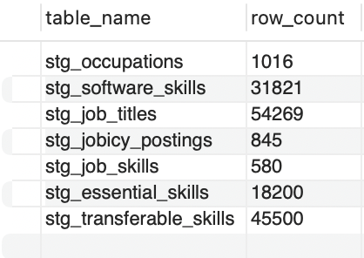
Figure 3. Staging tables after import.
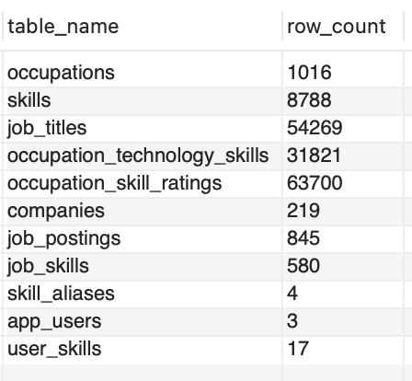
Figure 4. Core tables after File 2.
The one skills table holds 8,753 Technology, 10 Essential and 25 Transferable skills (Figure 5). Four Jobicy keywords reach their O*NET skill through an alias, and the other six match an O*NET name exactly (Figures 6 and 7). No keyword is left as a separate Jobicy-only skill.
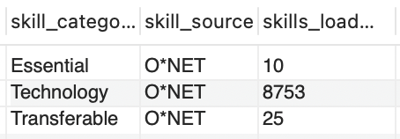
Figure 5. Skills by category and source.
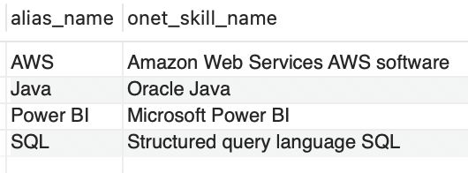
Figure 6. Skill aliases.
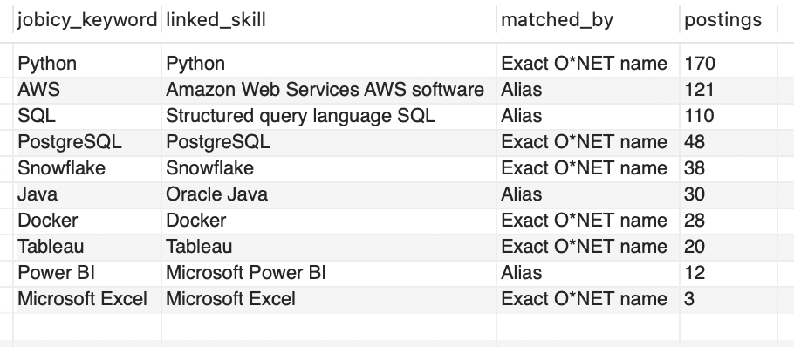
Figure 7. How each Jobicy keyword was linked, with the number of postings.
File 2 assigns five named roles from title keywords. Other postings are Other Tech when the title or the Jobicy industry is technical, and Non-Tech otherwise (Figure 8). Figure 9 shows the demo profiles.
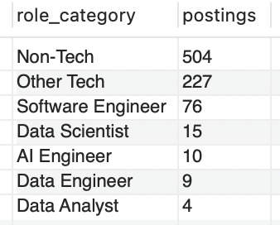
Figure 8. Postings by role category.
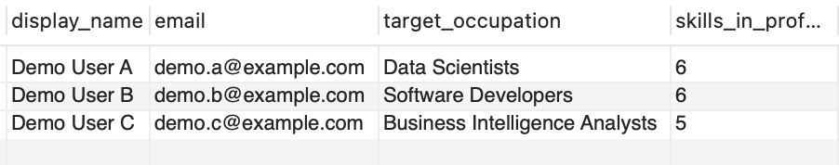
Figure 9. The three demo user profiles.

3.2 CRUD operations
The CRUD demo (File 2, Step 13) manages a user profile the way the app will. It runs inside one transaction that ends with ROLLBACK, so the database is unchanged afterwards.
Create. A new user signs up with Business Intelligence Analysts as the target and adds three skills at proficiency 3.
INSERT INTO app_users (display_name, email, target_occupation_id, is_demo)
VALUES ('CRUD Demo User', 'crud.demo@example.com', '15-2051.01', 1);
SET @crud_user_id = LAST_INSERT_ID();
INSERT INTO user_skills (user_id, skill_id, proficiency)
SELECT @crud_user_id, skill_id, 3 FROM skills
WHERE (skill_name, skill_category) IN (('Microsoft Excel', 'Technology'),
('Structured query language SQL', 'Technology'), ('Writing', 'Essential'));
Read. The profile is read with its target occupation and skills. It shows three rows for Business Intelligence Analysts, each at proficiency 3.
[Insert screenshot: the profile before the update]
Update. The user changes the goal to Data Scientists and improves at SQL.
UPDATE app_users SET target_occupation_id = '15-2051.00'
WHERE user_id = @crud_user_id;
UPDATE user_skills SET proficiency = 4
WHERE user_id = @crud_user_id
AND skill_id = (SELECT skill_id FROM skills
WHERE skill_name = 'Structured query language SQL'
AND skill_category = 'Technology');
Reading the profile again shows Data Scientists as the target and SQL at proficiency 4. The app's next screen, the new target's top missing skills, is read from the occupation_skills view.
[Insert screenshots: the profile after the update, and the top missing skills]
Delete. The user deletes the account. The foreign key on user_skills uses ON DELETE CASCADE, so the profile's skills are removed with it.
DELETE FROM app_users WHERE user_id = @crud_user_id;
SELECT (SELECT COUNT(*) FROM app_users
WHERE user_id = @crud_user_id) AS profiles_left, -- 0
(SELECT COUNT(*) FROM user_skills
WHERE user_id = @crud_user_id) AS skills_left; -- 0
ROLLBACK;
[Insert screenshot: profiles_left = 0 and skills_left = 0]

3.3 Application-oriented queries
File 2 contains ten analytical queries (Table 4). Queries 8, 9 and 10 combine data from several sources and are explained in more detail below.
# | Question it answers | Main tables or views
1 | Which skills do Data Analyst postings mention most? | market_skill_demand
2 | How do Data Analyst and Data Scientist postings differ in the skills they mention? | market_skill_demand
3 | How many postings are there per role and geographic eligibility? | job_postings
4 | Which tools does O*NET mark In Demand for Data Scientists? | occupations, occupation_technology_skills, skills
5 | Which postings have a title that matches an O*NET title exactly? | job_postings, occupations
6 | Which Essential and Transferable skills matter most for Data Scientists? | occupation_skill_ratings, skills
7 | How many skills of each category are linked to Data Scientists? | occupation_skills view
8 | How often do postings mention each skill, next to O*NET's Hot Technology and In Demand flags? | job_skills, skills, occupation_technology_skills
9 | Which important skills of a user's target occupation are missing from their profile? | app_users, user_skills, occupation_skills, job_skills
10 | How ready is each user for their target occupation? | app_users, user_skills, occupation_skills
Table 4. Analytical queries in File 2.

Query 8: market mentions next to O*NET flags
For each skill found in the postings, the query counts the postings that mention it and the occupations where O*NET marks it Hot Technology or In Demand. It joins the Jobicy data and the O*NET data through the shared skill_id. Python appears in 170 of the 845 postings (20.1%), AWS in 121 (14.3%) and SQL in 110 (13.0%). O*NET marks SQL as a Hot Technology in 151 occupations and Python in 132. Microsoft Excel is In Demand in 339 occupations but appears in only 3 postings, because the keyword list matches "Microsoft Excel" and not plain "Excel".
[Insert screenshot: query 8 output]

Query 9: a user's skill gap
This is the app's main question. A skill counts as needed when its importance is at least 3.5 out of 5, or when it is a technology that O*NET marks In Demand for the occupation. The query lists the needed skills that are missing from Demo User A's profile and ranks them by how often postings mention them. Demo User A targets Data Scientists and is missing 24 of the 30 needed skills. The top missing skills are AWS (121 postings), Snowflake (38), Tableau (20) and Power BI (12), followed by Mathematics (importance 4.38).
[Insert screenshot: query 9 output]

Query 10: readiness summary
The query summarizes query 9 for every user: the number of needed skills, the number the user has, and the percentage. Demo User C (Business Intelligence Analysts) holds 5 of 22 needed skills (22.7%), Demo User A holds 6 of 30 (20.0%) and Demo User B (Software Developers) holds 6 of 36 (16.7%).
[Insert screenshot: query 10 output]

Known limitations
- Jobicy lists only remote jobs, and the sample is skewed toward senior roles: 360 Senior and 306 Director postings against 14 entry-level ones.
- The keyword list has 10 skills, so only 282 of the 845 postings mention at least one.
- Role categories come from title keywords. Some roles have very few postings (4 Data Analyst postings in query 1).
- Exact title matching links only 28 postings to O*NET occupations, and most of them are non-tech roles such as sales representatives. A mapping from role to O*NET occupation is planned.

3.4 Reproducibility, attribution and documentation
The repository is organized as follows:
- data/: the original O*NET files (Onet/), the saved Jobicy responses (jobicy/raw/) and the cleaned CSVs (cleaned/).
- notebooks/: cleaning (01, 03), Jobicy collection and cleaning (02), and the two import notebooks.
- sql/: File 1 (create), File 2 (load, validate, query, CRUD) and JobAvenir_MySQL_README.txt, which lists the run order, the expected counts and troubleshooting steps.
- docs/: the database diagram. requirements.txt lists the Python packages. README.md describes the project, the setup steps and the changes.
To recreate the database, install MySQL 8.0 and the packages in requirements.txt, then run the four steps in 3.1. If the MySQL server does not use port 3306 (MAMP uses 8889), a .env file with MYSQL_PORT=8889 sets the port without editing the notebooks. Running File 2 a second time changes no counts.
Sources.
- O*NET 31.0 Database, U.S. Department of Labor, Employment and Training Administration, https://www.onetcenter.org/database.html. Used under the CC BY 4.0 license and modified by the team for cleaning and relational use.
- Jobicy remote jobs API, https://jobicy.com. Every posting keeps its Jobicy URL, as Jobicy asks.
- MySQL 8.0 Reference Manual and MySQL Workbench documentation, https://dev.mysql.com/doc/.
AI-use acknowledgement. ChatGPT (OpenAI) was used for planning, troubleshooting, code examples and README drafting. Claude (Anthropic) was used for code review and to write parts of the code and documentation: the consolidated MySQL schema and load script (Files 1 and 2), the import notebooks, the Jobicy collection changes, the database diagram, parts of the READMEs and a draft of this report. The team ran every script, checked the results and reviewed all text before submission.

Part 4: Individual Contribution Summary
[Draft from the Git history. Confirm or correct each row and fill in the hours.]
Team member | Contributions to database design, implementation and testing | Estimated time
Mounika Kage | Reviewed and fixed the data pipeline. Consolidated the skills design into one skills table. Added the skill aliases and the user tables. Ran the broad Jobicy collection. Rebuilt and tested the database in MySQL Workbench on MAMP. Captured results and wrote the report. | [__ hours]
Sheetal Sreedhar | Set up the repository. Explored and cleaned the O*NET occupation, software skill and job title data. Built the first Jobicy collection and the first MySQL schema and load scripts. Cleaned the Essential and Transferable skill data, loaded it into MySQL and wrote the README. | [__ hours]
Table 5. Individual contributions.

Personal statement: Mounika Kage
[Write three or four sentences in your own words: what you built or tested, and which parts of the database you can explain (for example the skills design, the aliases, the user tables and the CRUD demo).]

Personal statement: Sheetal Sreedhar
[Write three or four sentences in your own words: what you built or tested, and which parts of the database you can explain (for example the O*NET cleaning, the first schema and the Essential and Transferable skill loading).]

